**DAILY ONLINE ACTIVITIES SUMMARY**

|  |  |  |  |  |  |  |  |  |
| --- | --- | --- | --- | --- | --- | --- | --- | --- |
| **Date:** | **01-06-2020** | | | | | **Name:** | **JAYANTH S V** | |
| **Sem & Sec** | **VIII Semester & A Section** | | | | | **USN:** | **4AL16CS041** | |
| **Online Test Summary** | | | | | | | | |
| **Subject** | | **SMS** | | | | | | |
| **Max. Marks** | | **60** | | **Score** | | | **60** | |
| **Certification Course Summary** | | | | | | | | |
| **Course** | **Introduction to Ethical Hacking** | | | | | | | |
| **Certificate Provider** | | | **Great Learning** | | **Duration** | | | **6 Hours** |
| **Coding Challenges** | | | | | | | | |
| **Problem Statement: Find the leaders in the array.** | | | | | | | | |
| **Status: COMPLETED** | | | | | | | | |
| **Uploaded the report in Github** | | | | | **YES** | | | |
| **If yes Repository name** | | | | | **Jayanth-Sv** | | | |
| **Uploaded the report in slack** | | | | | **YES** | | | |

Online Test Details:

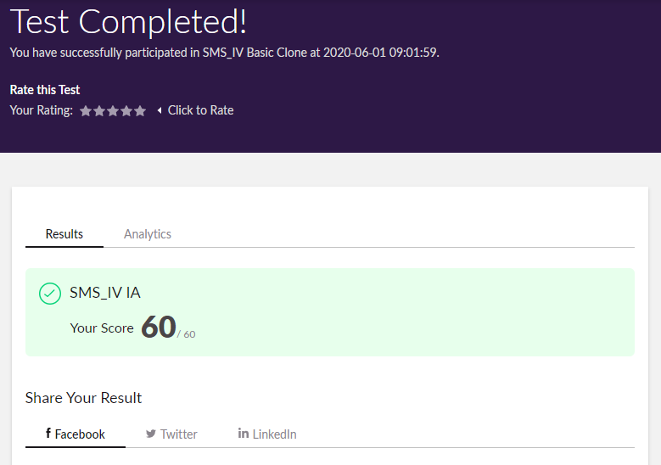

Coding Challenges Details:

|  |  |
| --- | --- |
|  | |
|  | |
|  | |
|  | |
|  | |
|  | |
|  | |
|  | |
|  | |
|  | |
|  | |
|  | |
|  | |
|  | |
|  | |
|  | |
|  | |
|  | |
|  | |
|  | |
|  | |
|  | |
|  | |
|  | |
|  | |
|  | |
|  | |
|  | |
|  | |
|  | |
|  | |
|  | |
|  | |
|  | |
|  | |
|  | |
|  | |
|  | |
|  | |
|  | |
|  | |
|  | |
|  | |
|  | |
|  | |
|  | |
|  | |
|  | |
|  | |
|  | |
|  | |
|  | |
|  | |
|  | |
|  | |
| **#include<stdio.h>** |
|  |  | |
|  | **void main()** | |
|  | **{** | |
|  | **int n, i, j, a[10];** | |
|  | **printf("Enter the value of n: ");** | |
|  | **scanf("%d",&n);** | |
|  |  | |
|  | **printf("Enter the numbers:\n");** | |
|  | **for(i=0;i<n;i++)** | |
|  | **scanf("%d",&a[i]);** | |
|  |  | |
|  | **printf("The leaders are\n");** | |
|  | **for (int i = 0; i < n; i++)** | |
|  | **{** | |
|  | **j = 0;** | |
|  | **for (j = i+1; j < n; j++)** | |
|  | **{** | |
|  | **if (a[i] <= a[j])** | |
|  | **break;** | |
|  | **}** | |
|  | **if (j == n)** | |
|  | **printf("%d ",a[i]);** | |
|  | **}** | |
|  | **}** | |